Graphics lies, misleading visuals

By Mousfiqul Islam Khan

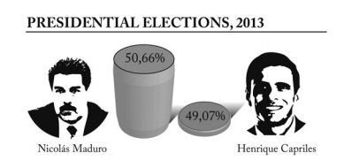

This picture represents the presidential election results in Venezuela. The picture was published by TVE, the Spanish broadcasting system on September 2013. Source (<https://infovis.fh-potsdam.de/readings/Cairo2015.pdf>)

The picture was intended for the Venezuelan people, specifically the ones who supported Nicolas Maduro so that they don’t get discouraged that he won by small margins. I know this because it’s mentioned on the paper.

In the graph, the graphic is misleading, it has a 3D effect with only y-axis, and the effect give the impression that Nicolas won by huge margins but the true numbers are very close to each other. And this was published on TV so a viewer wouldn’t get enough time to make sense of it, they’ll only see the graphics and believe what is shown. If there was a 2D graph with a starting zero and appropriate numbering then the data will feel truer.